**NAME: LAVANYA S**

**REG NO: 212222070017**

**DEPT: EIE**

**DATE:23.04.2025**

**EXP NO:8**

**Reproducing an Image Using Prompts for Image Generation**

**Aim:**

To demonstrate the ability of text-to-image generation tools to reproduce an existing image by crafting precise prompts. The goal is to identify key elements within the image and use these details to generate an image as close as possible to the original.

**Example Structure for a Prompt:**

**Setting:** Describe the location or background (e.g., city street, forest, beach).

**Subject(s):** Mention the main focus (e.g., a person, an object, or animals).

**Colors and Lighting:** Include specific color tones and the effect of light (e.g., sunset with warm golden light, dim lighting with neon signs).

**Use a Text-to-Image Generation Tool:** Input the prompt into a text-to-image tool (like DALL·E, MidJourney, or Stable Diffusion) to generate the image.

**Review and Refine:** Compare the generated image with the original. Adjust the prompt as needed by adding more details or tweaking the description to improve the likeness.

**Example of Reproducing an Image Original Image Description:**

**Scene:** A forest during early autumn with vibrant orange, yellow, and red leaves. The sun is low on the horizon, casting a soft golden glow over the scene. A deer stands gracefully near a small, tranquil stream.

**Generated Prompt:**

“An autumn forest scene with vibrant orange, yellow, and red leaves scattered across the ground and trees. The sun is setting low on the horizon, casting a warm golden light over the landscape. A graceful deer stands near a tranquil stream, with soft reflections of the trees in the water.”

**output:**

This image was created based on the description of vibrant autumn foliage, a sunset, and a deer near a tranquil stream

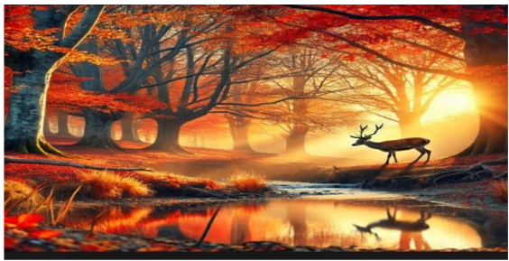

**Result:**

This experiment demonstrates the power of text-to-image generation tools in recreating a visual scene from a carefully crafted prompt. The key to success is in the precision of the prompt, ensuring that all critical elements of the original image are included in the description. By refining and adjusting the prompts as needed, text-to-image tools can be optimized to produce highly accurate reproductions of existing images.